IS5312 Analytical Programming with Python
Project Description

Project Objectives
In this project, you will practice manipulating data files, processing data, conducting exploratory data analysis, and making predictions based on data. This project has two objectives:
- By conducting this project, students can review and comprehensively practice most Python programming skills learned from this course:
    - Numbers and variables
    - Input and output
    - Relational operations
    - Strings
    - List and tuple
    - Set and dictionary
    - If-else control flow
    - For and while loop control flow
    - File processing
    - Functions
    - Class
    - Numpy
    - Pandas
    - Visualization/Matplotlib
    - Linear/Logistic regression
    - Decision tree
    - Scikit-learn library
- Some tasks in this project will include some programming skill that are a little beyond the above listed points but still with reasonable difficulty level. The rationale is that when programming, it is very usual to come across new problems you have never seen before, especially considering the rapid development of programming technology and tools. Hence, it is necessary to train students to solve new problems creatively. This project is designed to induce students to train their creative problem-solving skills when facing new programming tasks. With the help of references from books, papers, and Internet, students can solve these tasks successfully.

Data Description
This project uses two data files. The first file, variables.txt, provides detailed definitions of each variable in the dataset. The second file, SpeedDating.csv, contains data collected from participants in experimental speed dating events.
During these events, attendees participated in four-minute 'first dates' with every other participant of the opposite sex. After each interaction, participants were asked if they would like to see their date again. If both individuals agreed to see each other again, it was considered a 'match' (represented by the last variable in the dataset). If either partner was unwilling, it was not considered a match.
The SpeedDating.csv file contains a total of 7,644 observations and 33 variables. These variables can be classified into five categories:
- Personal Background: This category includes demographic information, such as age and gender.
- Background Similarity: These variables capture the similarity between 'dated' participants in terms of attributes like race or hobbies.
- Numerical Rating on Self/Partner: Participants rated both themselves and their partner on various characteristics, such as attractiveness and humor.
- Willingness to Match: These variables reflect a participant's extent of willingness to find a matched partner during the event.
- Dependent Variable - 'Match': Whether a match was made between participants

Tasks
You need to write Python programs to finish the following tasks, and manual manipulations do not count in your score. Please note that ALL questions are mandatory, questions with missing answers will result in deduction of grades. No bonus marks will be rewarded for extra work.

Data cleaning (25%)
- (10%) Read data from txt file.
  - Please write code to read the file named variables.txt.
  - Please write code to delete the brief introduction content at the first two lines of the file, delete the column of Definition and Types, only keep the variable names as a list.
- (15%) Pre-processing data and store new data into CSV file
  - Please read SpeedDating.csv as a dataframe. add column names to the dataframe with the above variable names.
  - There are observations with missing values in this data. Write code to remove these observations and then display the number of observations remaining after removal.
  - Convert the categorical variable 'gender' into binary form, where 1 represents 'male' and 0 represents 'female'
  - Variables 'samerace' and 'match' contain string values that need to be converted. Convert these categorical variables into binary form, where 1 represents 'same race' or 'matched', and 0 represents 'different race' or 'not matched', respectively. For example, b'0' should be converted into 0, while b'1' should be converted into 1.
  - Please store the combined dataset into a new CSV file named dataforanalysis.csv.

Exploratory data analysis (40%)
To overview the distribution of data in the dataset, you need to conduct the descriptive statistics:
- (10%) Please find all numerical variables, conduct descriptive statistics and draw histograms of the variables.
- (15%) Please calculate the age difference of variables “Age” and “age_o” for each observation.
  - Add the age differences as variable “age_d” in a new column in the dataframe.
  - Draw a bar chart to show the age difference distribution. The x-axis should be age difference groups, and the y-axis should be the number of observations having this age difference. Below is an example of the expected bar chart.
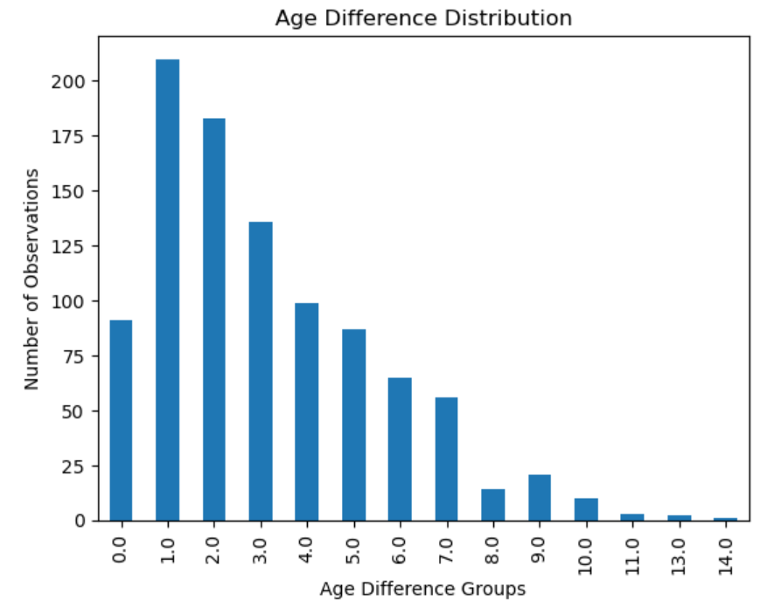
- (15%) In the dataset, each participant assigns a total of 100 points across six qualities they would like to see in a partner: “attractive_important”, “sincere_important”, “intelligence_important”, “funny_important”, “ambition_important”, and “shared_interests_important”. The points they assign represent the importance of each quality to them. After participants rate their partner, the scores are stored in “attractive_partner”, “sincere_partner”, “intelligence_partner”, funny_partner”, “ambition_partner”, and “shared_interests_partner”.
  - For the first participant, draw a pie chart to display the importance of each quality, you can choose any color combination for the chart.
  - Please calculate relative scores for each quality based on the importance of each quality and the score that participant give to their partner. Add these relative scores as new variables in the dataframe. For example, the relative score of attractiveness can be calculated by:
$$relative_attractive=attractive_partner× \frac{attractive_important }{100}$$

Partitioning data and predicting attrition (35%)
- (5%) Partitioning the dataframe outputted from 3.2 into train data set and test data set. The train data set should be about 80% of all data points and the test data set should be 20% of them.
- (15%) Write a program to predict matching results in the social event based on other variables in the file, using the 'match' attribute as the target. Please construct the prediction model as a function/functions and call the function(s) when making prediction. The prediction models should be chosen from those covered in class (such as decision trees or other models).
- (15%) Evaluating the prediction results. The classification_report and plot_confusion_matrix functions can be used to check the model performance.
- Submission Files
To obtain scores of the project, you need to submit these files:
- An outputted .html file containing all your source codes and the running results by the order of tasks from the Jupyter Notebook. To name this file, please follow this format: studentNameStudentNumberprojectcode.html. For example, if you are CHAN Wai Ting and your student No. is 55664332, then your submitted source code file should be named as CHANWaiTing55664332projectcode.html. Please put all source codes into one file for the ease of grading.
- The CSV file generated during Tasks 3.1.
- A report on the results of exploratory data analysis (Task 3.2) and match prediction (Task 3.3), with four pages at most. To name this file, please follow this format: studentNameStudentNumberprojectreport.pdf. For example, if you are CHAN Wai Ting and your student No. is 55664332, then your submitted report file should be named as CHANWaiTing55664332projectreport.pdf.

